
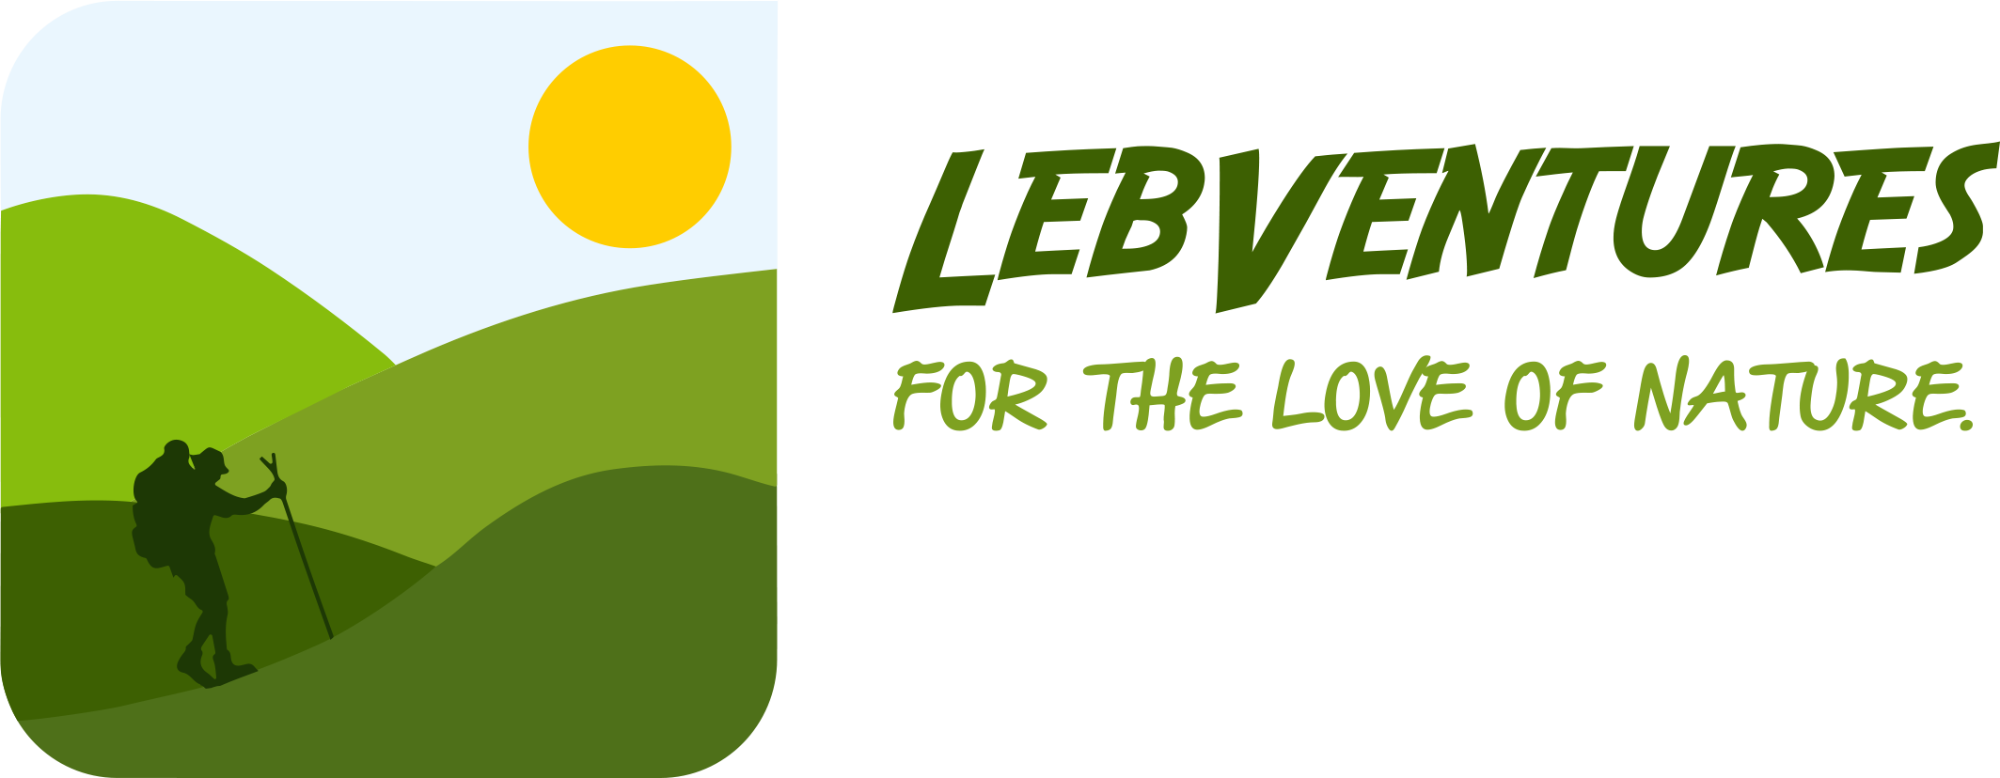
Lebventures

For the Love of Nature

STARTUP BUSINESS PLAN

2025

Gioia Wehbe
Amchit, El Tine Street | 70-050590

lebventures.lebanon@gmail.com www.lebventures.com

1.


Executive Summary

Business Overview

Mission Statement

Product/Service Summary

Market Opportunity Summary

Traction Summary

Next Steps

Vision Statement

Capital Request

Business Overview

Lebventures is a family-founded tour operator specializing in adventure tourism. We organize diverse outdoor experiences, including hiking, camping, rock climbing, and customized eco-tours, tailored for all adventure levels. Lebventures stands out by offering inclusive outdoor adventures for all ages and skill levels, fostering a deep connection with nature through sustainable and immersive experiences. Founded in 2019 by Pierre Abboud and Gioia Wehbe, a married couple passionate about outdoor adventure, Lebventures aims to share their lifestyle with the public while preserving it for future generations. Managed and operated by the founders, Lebventures is a Limited Liability Company (LLC/SARL) based in Byblos, operating across Lebanon. Looking ahead, Lebventures seeks to grow by partnering with local communities, developing new adventure routes, and exploring eco-tourism opportunities beyond Lebanon.

Mission Statement

Our mission is to inspire people of all ages to reconnect with nature by transforming life into an outdoor adventure through immersive experiences, while promoting sustainability for future generations.

Product/Service Summary

Services:
- Land Adventures: Hiking, climbing, camping, biking, and caving, offering thrilling experiences for all skill levels.
- Water Activities: Snorkeling, fishing, and kayaking in Lebanon’s scenic waters.
- Winter Experiences: Snowshoeing excursions through breathtaking snowy landscapes.
- Leisure & Exploration: Stargazing, archery, and picnicking for a more relaxed connection with nature.
- Kids Educational & Sensory Experiences: Outdoor activities and events designed to engage children in nature through hands-on learning and sensory exploration.

Products:
- Hike to Paint – MACAM: A guided hike ending with a creative painting session at the Modern and Contemporary Art Museum.
- Billion Star Hotel – Camping & Stargazing: An unforgettable camping experience under a star-filled sky.
- Bull’s Eye Picnic – Archery & Picnicking: A combination of archery practice and a relaxing outdoor picnic.
- Snow and Fire – Snowshoeing & Bonfire: A winter adventure featuring snowshoeing followed by a cozy bonfire.
- Muddy Trail – Rainy Hike, Mud Games & Snail Picking: A fun-filled adventure embracing the beauty of Lebanon’s rainy season.
- The Hermit Experience – Qadisha Valley: A spiritual and cultural journey exploring the solitude of Lebanon’s ancient hermit caves.
- Biking the Phoenician Routes – Byblos: A scenic cycling adventure through historic Phoenician trade routes.
- Mountains to Sea – Batroun Edition: A diverse exploration from Batroun’s mountain trails to its stunning coastline.
- Mountains to Sea – Byblos Edition: A similar mountain-to-sea adventure, uncovering the natural beauty of Byblos.
- Hike into History–Telten l Bled: A cultural hiking experience exploring ancient villages and historical landmarks.
- Go Vertical: A thrilling rock-climbing event combined with a lively beer festival.
- Rural Living Experiences – Zouwede / Al Zourou3 / Bchalleh: A deep dive into authentic rural life with hands-on experiences in Lebanese villages.
- Stalactite – Caving in Afqa: A thrilling underground adventure exploring the stunning caves of Afqa.
- Little Explorers – Family Hike & Sensory Adventure: A fun and educational outdoor experience designed for kids and families, featuring an easy hike combined with interactive sensory and nature-based activities.

Market Opportunity Summary

Industry Growth and Demand
Lebanon’s tourism sector contributed $5.41 billion in 2023 (30.2% of GDP), with eco-tourism gaining momentum. The country’s versatile geography—ranging from Mediterranean shores to rugged mountains and hidden caves—makes it a prime destination for adventure seekers.

Established initiatives like the Lebanon Mountain Trail (470 km across 76 villages) highlight the rising demand for sustainable outdoor experiences. As interest in nature-based tourism grows, Lebventures is uniquely positioned to offer immersive, eco-friendly adventures tailored to all skill levels.

Target Market
Lebventures serves a wide variety of customers, from nature enthusiasts to families, corporate groups, eco-conscious travelers, and cultural explorers. Each segment presents distinct motivations, which Lebventures is equipped to address with tailored experiences.

- Adventure Seekers
  - Demographics: Primarily adults aged 18-45, both local and international tourists.
  - Psychographics: Individuals seeking active outdoor experiences such as hiking, climbing, and biking. They value fitness, exploration, and a deep connection with nature.
- Families
  - Demographics: Families with children looking for outdoor adventures suitable for all ages and skill levels.
  - Psychographics: Parents eager to engage their children in fun, educational, and sensory outdoor activities, focusing on creating lasting memories through shared experiences.
- Eco-Conscious Travelers
  - Demographics: Tourists from Lebanon and abroad who prioritize sustainable tourism.
  - Psychographics: Customers who seek eco-friendly travel, conservation, and responsible engagement with nature.
- Expatriates, Locals, and Lebanese Diaspora
  - Demographics: Expats, Lebanese locals, and diaspora members from the Middle East, Europe, and the Americas.
  - Psychographics: Individuals eager to reconnect with Lebanon’s outdoors, heritage, and rural traditions. Many seek a slower-paced, immersive escape from urban life.
- Corporate Groups & Team Building
  - Demographics: Companies seeking team-building exercises and retreats.
  - Psychographics: Businesses aiming to enhance collaboration, leadership, and morale through outdoor group challenges.
- Tour Operators/Travel Agencies
  - Demographics: Local and international agencies seeking reliable outdoor partners.
  - Psychographics: Agencies seeking safe, professional, and authentic experiences to include in premium travel packages.

Market Gap

Despite strong sector growth and a diverse customer base, several needs remain underserved. These market gaps present high-potential opportunities for differentiation and innovation:

- Lack of Family-Friendly Adventure Options
  - Gap: Few outdoor activities in Lebanon are designed specifically for families, especially those that are both safe and enriching.
  - Opportunity: Lebventures can create family-friendly adventures that combine fun with education, offering inclusive experiences for all ages.
- Growing Demand for Eco-Tourism & Sustainable Travel
  - Gap: Demand for sustainable travel is rising, but few providers fully integrate eco-conscious practices.
  - Opportunity: Lebventures can lead with low-impact adventures and conservation-focused experiences.
- Limited Cultural & Heritage-Focused Tours
  - Gap: Many tour providers separate nature from culture, missing opportunities for integrated storytelling.
  - Opportunity: Lebventures can offer nature-based experiences that also highlight Lebanon’s history, traditions, and identity.
- Undeveloped Rural Tourism Sector
  - Gap: Rural areas remain under-visited and underdeveloped for tourism.
  - Opportunity: Lebventures can promote rural tourism through immersive, community-driven experiences, supporting local economies.
- Limited Customization for Niche Markets
  - Gap: Most tour offerings are generic, lacking options for specialized groups.
  - Opportunity: Lebventures can stand out by offering flexible packages tailored to specific interests and goals.
- Underutilization of Lebanon's Water-Based Tourism Potential
  - Gap: Rivers, lakes, and coastline remain largely untapped, particularly outside summer months.
  - Opportunity: Lebventures can activate this potential with seasonal water-based activities like kayaking and snorkeling, attracting both adventure seekers and eco-conscious travelers.
- Tourism Infrastructure and Service Quality
  - Gap: Inconsistent service and limited infrastructure, especially in remote areas, impact visitor experience.
  - Opportunity: Lebventures can set a new standard by offering well-organized, high-quality service supported by professional guides and logistics.

Competitive Advantage
To meet these unmet needs, Lebventures offers a distinct value proposition that goes beyond conventional eco-tourism
- Unmatched Diversity of Experiences
From water-based adventures to cultural hikes and rural village immersions, our offerings span Lebanon’s full natural and cultural spectrum including locations often overlooked by mainstream providers.
- Tailored, Inclusive Adventures
We create flexible, fully customizable itineraries for families, solo travelers, corporate teams, and niche groups ensuring accessibility, comfort, and relevance for a broad audience.
- Authentic Local Integration
We collaborate with local communities, artisans, and guides to provide genuine, off-the-beaten-path experiences that support and celebrate local heritage.
- True Sustainability, Not Just a Buzzword
Sustainability is built into everything we do from eco-friendly logistics to direct community involvement ensuring ethical travel with real impact.
- Professionalism with Passion
Our team of experienced planners and guides bring enthusiasm and deep local knowledge to every adventure, ensuring safety, quality, and unforgettable memories.
- Educational, Family-Friendly Experiences
We design experiences that are both fun and enriching. Families benefit from hands-on learning, nature discovery, and cultural immersion that engage all ages and spark curiosity.

